**Open meeting on Friday, 8th November**

🗓 **Date:** Friday, 8th November  
🕢 **Time:** 7:30 pm  
📍 [**Join us via Zoom**](https://us02web.zoom.us/j/86797100942?pwd=d2U1OUtIRXV4KzNiZVRwUmhKUWZTZz09&link_id=0&can_id=7c4454100256314e5d12de0b6f26aa58&source=email-join-us-for-our-next-open-meeting-with-special-guest-jeff-hooper&email_referrer=&email_subject=join-us-for-our-next-open-meeting-nil-with-special-guest-jeff-hooper)

Join us for the monthly Winchester Green Party news updates and to hear from our special guest speaker, **Jeff Hooper**, Chairman of BioPotatoes. Jeff’s background in molecular genetics and potato research has led him to develop innovative potato varieties that tackle global challenges in food security and environmental sustainability.

During his time as CEO of Twyford Plant Laboratories in the 1980s and 90s, he established a genetics lab at Cambridge Science Park to explore potato modification, working with leading food processors.

In 2010, Jeff founded BioPotatoes to develop potato varieties using advanced GM technology. His work addresses two major global challenges:

* The urgent need for disease and pest resistant potato varieties that also offer significant benefits to growers, processors, and consumers.
* The gap left by large biotech companies, which have opted not to focus on potato research in their R&D programs.

BioPotatoes' mission is to create better potato varieties that benefit not only consumers and growers but also the environment – globally.

**Q&A session** to follow Jeff’s presentation. Don’t miss this chance to learn about the potential future of agriculture!

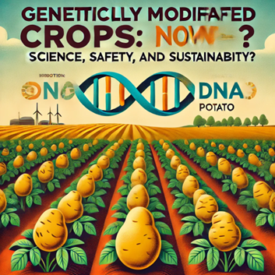

Mark your calendars—we look forward to seeing you online!

For any questions about this event please contact: [lorraine.estelle3@gmail.com](mailto:lorraine.estelle3@gmail.com) or [greendannylee@gmail.com](mailto:greendannylee@gmail.com)